ThermaCube

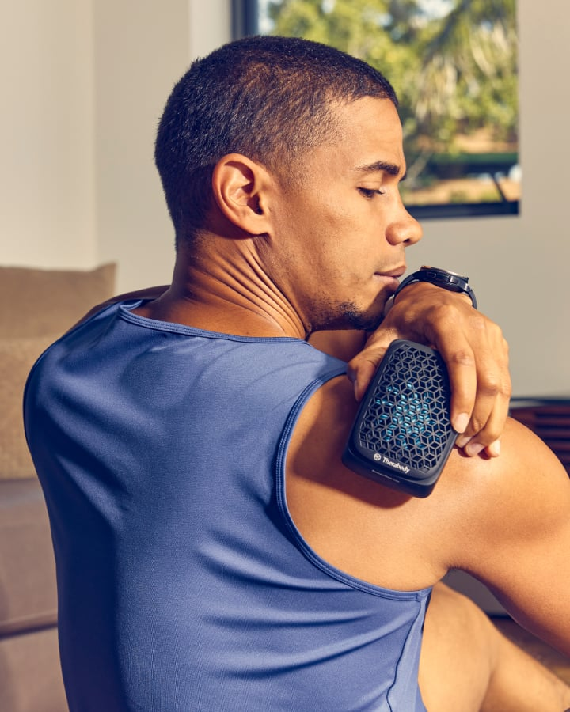
The Recovery ThermCube is a compact, reusable device that delivers instant cold, heat and contrast therapies scientifically proven to treat injuries, relieve pain, reduce inflammation and maximize muscle and joint recovery. The Cube has simple pre-set treatments that use scientifically-optimized temperatures and durations for effective relief and recovery anywhere on the body. Plus, Cube is wearable, portable and convenient for relief anytime you need it.

Benefits:

Heat Therapy:
- • Reduces soreness + stiffness
- • Decreases muscle spasms
- • Increases circulation
Cold Therapy:
- • Reduces inflammation and swelling
- • Relieves joint, muscle and soft tissue pain
Contrast Therapy:
- • Combines benefits of cold and heat therapies
- • Maximizes joint and muscle recovery
Using the ThermaCube

Securely rest the device on the intended treatment area, and long press either the cold or hot button to power the device on and begin treatment. If placing the device on the intended treatment area makes the cold and hot buttons out of reach, power on and choose your treatment first.

Cold Therapy
Long press the cold (snowflake) button to begin cold treatment. The cold button will illuminate as blue as the cold treatment begins. Short press the cold button at any point during treatment to toggle through temperature options: 1 LED light: 16 ℃ (61 ℉) (default), 2 LED lights: 12 ℃ (54 ℉), 3 LED lights: 8 ℃ (46 ℉). The treatment will run for 18 minutes.

Heat Therapy
Long press the hot (heat wave) button to begin hot treatment. The hot button will illuminate as orange as the hot treatment begins. Short press the hot button at any point during treatment to toggle through temperature options: 1 LED light: 35 ℃ (95 ℉) (default), 2 LED lights: 39 ℃ (102 ℉), 3 LED lights: 43 ℃ (109 ℉). The treatment will run for 24 minutes.

Contrast Therapy
For contrast mode, simultaneously long press both the cold and hot buttons. Both the cold and hot buttons will illuminate as the contrast treatment begins. The treatment will run for 20 minutes, spending five minutes in cold treatment and five minutes in hot treatment, and repeating once. Short press the cold or hot button at any point during their respective treatment to toggle through temperature options (Cold: 3 LED lights: 8 ℃ (46 ℉) (default), 1 LED light: 16 ℃ (61 ℉), 2 LED lights: 12 ℃ (54 ℉); Hot: 3 LED lights: 43 ℃ (109 ℉) (default), 1 LED light: 35 ℃ (95 ℉), 2 LED lights: 39 ℃ (102 ℉).Treatment times do not reset when the treatment temperature is changed. Treatment times do reset when switching between hot and cold treatment. The device will power off once the treatment is complete. Long press the cold or hot button to turn off the device.

RecoveryTherm Cube can be used as a handheld device or securely fastened to the treatment area using the Cube Strap Frame and straps provided. Use the device directly on the skin to maximize benefits or through light clothing if desired. To use as a handheld device, place the device on the intended treatment area with the Therabody logo facing out. Grip the device using the recommended flat grip area on each side. Do not cover air vents or lay on top of the device. Use the device by either holding it still on the treatment area or gently massaging.

Please wipe down ThermaCube and any used straps with a sanitation wipe after each use.

