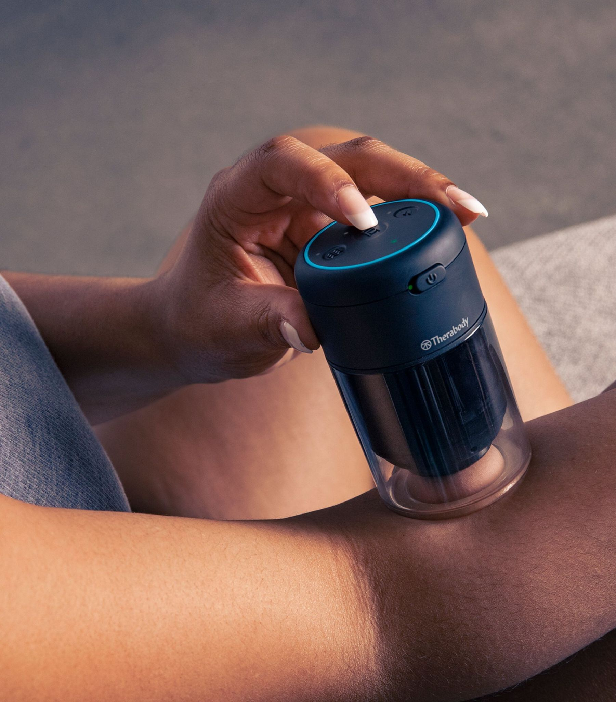
TheraCup
TheraCup combines traditional cupping with our cutting-edge ThermaVibration™ Technology. It brings suction, heat, and vibration together to create an easy-to-use digitized cupping experience that optimizes localized relief and recovery. With built-in safety sensors and on-device controls, TheraCup safely brings professional-level therapy to the comfort of home.
These recommendations are derived from consultation with medical experts and the published research in regards to precautions and contraindications for myofascial interventions.

Using the TheraCup
Pinpoint an area of soft tissue to be treated with the TheraCup. Ensure the area is relaxed and you are able to pinch a fair amount of tissue into your hand. Switch the device to the on (green) position and push the center top button to turn on the suction function. Press the center button once for light suction, press twice for medium suction, press three times for heavy suction. You may also adjust the strength of the vibration function as well as the quality of the heating element by pressing on the buttons to the left and right of the center top button. They are marked with vibration and heat symbols.
The duration of each cycle of treatment is 3 minutes long, unless you turn off the TheraCup beforehand. You may utilize the TheraCup in a variety of ways including light gliding and simply allowing it to rest in one area of restriction for the entire period of time. The TheraCup will shut off on its own at the end of the cycle or you may press down the top center button until it turns off the unit.

Precautions:
Due care is required in these circumstances and the use of the devices may need to be modified. Where appropriate or if you have any concerns, seek the advice of a medical professional.
- Recent injury or surgery
- Pregnancy Diabetes
- Osteopenia
- Osteoporosis
- Hypertension (controlled)
- Abnormal sensations (e.g., numbness)
- Bony prominences or regions
- Sensitivity to heat, vibration, or pressure
- Mild peripheral neuropathy
- Do not wear this device overnight while sleeping
Contraindications:
The following are circumstances where the potential risks may outweigh the benefits. Therefore, it is advised that you should seek the advice of a medical professional before using the device.
- Skin rash, open wounds, blisters, local tissue inflammation, infections, bruises, or tumors
- Skin conditions such as eczema or psoriasis
- Bone fracture or myositis ossificans
- Osteomyelitis
- Severe scoliosis or spinal deformity
- Hypertension (uncontrolled)
- Vascular/arterial and circulation diseases, including blood clots, phlebitis, thromboses (DVT), and varicose veins
- History of embolism
- Acute or severe cardiac, liver, or kidney disease
- Severe peripheral neuropathy or other cause of sensory impairment
- Bleeding disorders
- Connective tissue disorders
- Medications that thin the blood or alter sensations
- Direct pressure over surgical site or hardware
- Direct application to the face, head, throat, neck, or genitalia Pacemaker or ICD
- Do not use in the presence of unexplained pain

Please wipe down TheraCup after each use and leave any used cup heads out to be hand-washed by the staff.

