Guided Brainwave Meditation:

The influence of sound waves on our mental and physiological states has been experiencing a growth in recent research indicating the positive effects certain wavelengths can have on our health. Certain frequencies of sound waves can have unique effects on our abilities to perform well, concentrate, improve sleep, and even dive deeper into our subconscious.

Benefits:
- Reduces pain and stress
- Improves concentration
- Improved sense of self and well being
- Improved sleep and recovery
- Improves performance
- Access to creative thinking
- Improves natural capacity for healing
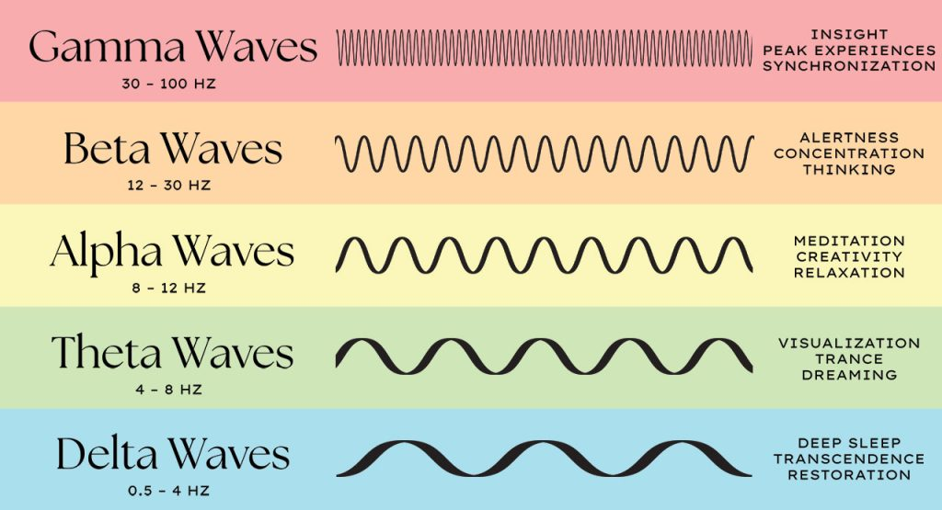
Overview of Sound Waves:
Delta Waves are known for promoting deep sleep, relief from pain, healing, and reducing the effects of aging.

Theta Waves are known for promoting deep relaxation, REM sleep, creativity, and meditative states.

Alpha Waves are known for promoting relaxed focus, reduction in stress, positive thinking, and learning capabilities.

Beta Waves are known for promoting focused attention, cognitive thinking, problem solving, and active movement.

Gamma Waves are known for promoting higher level cognition, memory recollection, and states of peak awareness.

How to Use Brainwave Meditations:

Set up a comfortable station on which you can rest your body. Sitting upright is best for meditations and lying supine (on your back) is also good for more restorative meditations/self-hypnosis sessions. Use any props that make your feel more comfortable including the mats, mat table, leg support wedges, blankets, eye pillow, bolster, and you may even dim the lights.

Using the provided noise canceling headphones, or your own headphones, pair them with the iPad or your own device.

There is a massive and ever growing amount of guided meditations out there for your access. Here are a couple of suggestions for guided meditation and self-hypnosis providers to get you started. They have a large library of tracks focusing on different themes including improving performance, letting go of negative attachments, manifesting dreams, recovery, disconnecting from social media, destresses, or even just tuning out.

You may even search for tracks that are solely sound based and deliver a particular set of soundwaves. For example, type in “Theta Meditation” into a search engine and you’ll be presented with tracks with theta waves improving your ability to drop in for meditative state, enhance creativity, and promote REM sleep.

For Spotify tracks visit:

Micahel Sealy
https://open.spotify.com/artist/6jjasZDQfYIoKLynD807L1?si=kGoAa7E1R4-21sw5LSf3jA

Kelly Howell
https://open.spotify.com/artist/4KYmHtXXlx6QOA4h38Mqjp?si=0UPd35PySbeGnnWT0Re3nQ

For YouTube tracks visit:

Michael Sealy
https://www.youtube.com/@MichaelSealey

Kelly Howell
https://www.youtube.com/channel/UCqTTgurtOXGKuqj0EfD-D1Q

Please wipe down any headphones and or equipment used with a sanitation wipe after each use.

