PowerDot

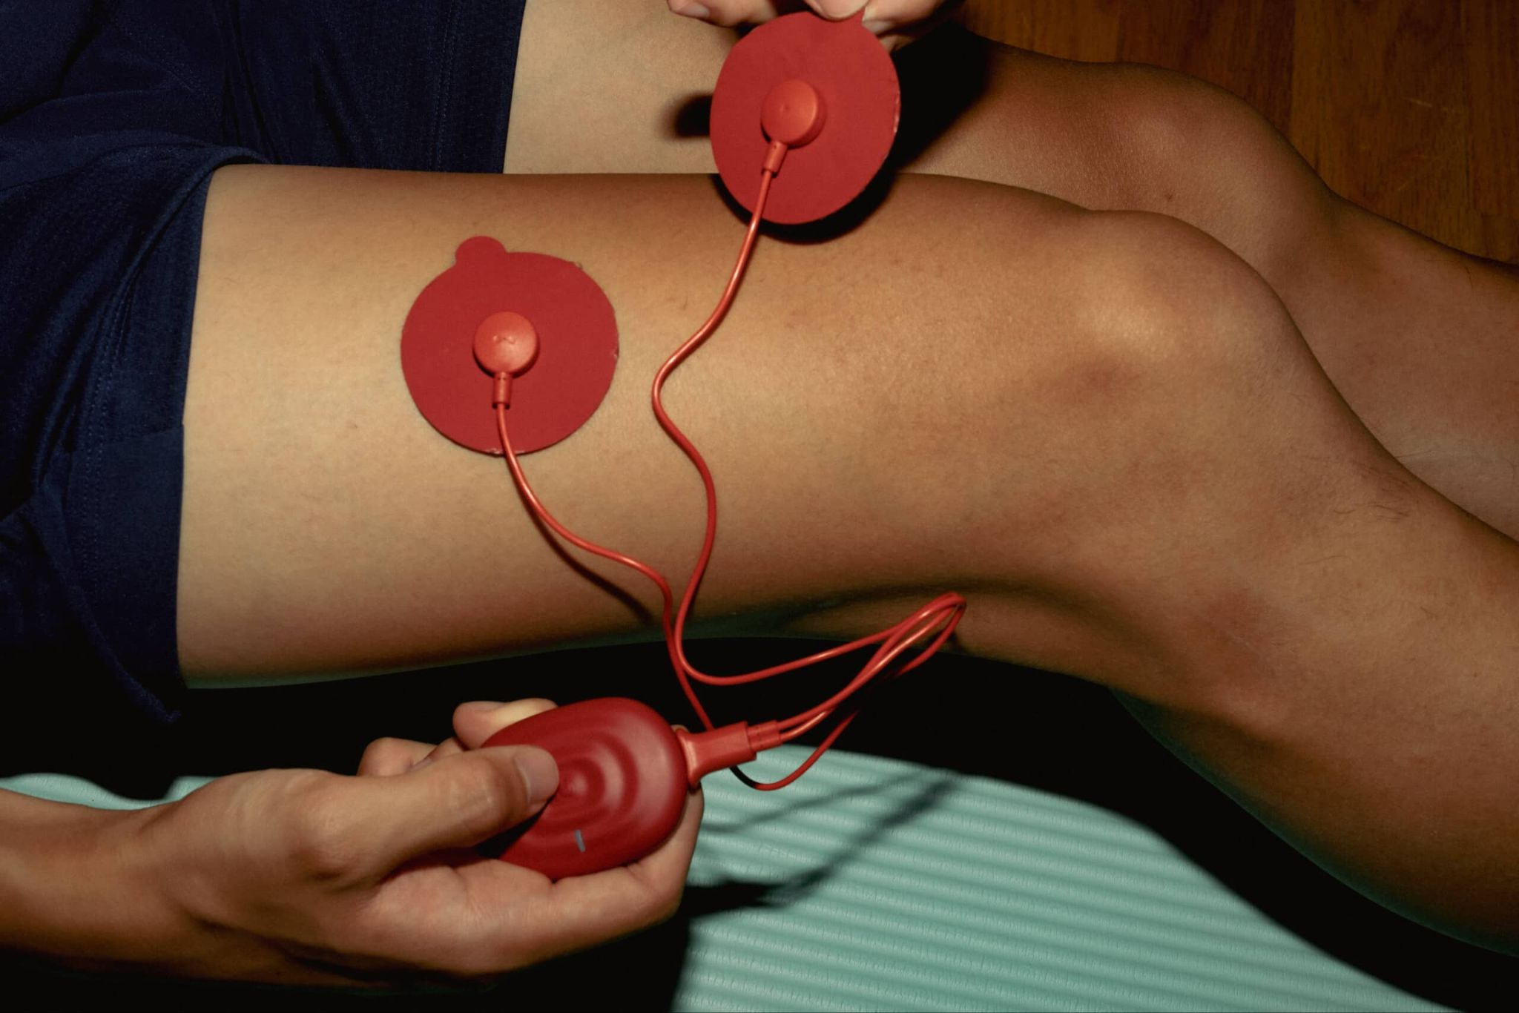
This powerful muscle stimulator packs the proven concepts of NMES & TENS into a sleek lightweight pod you can use anywhere. Fully controlled by the PowerDot app, it takes the guesswork out of electrical muscle stimulation by guiding and customizing your intensity and pad placement. Trusted by everyone from the world’s top athletes, to fitness enthusiasts, and beyond.

Benefits:

- Relieves pain
- Speeds up muscle recovery
- Improves performance
- Period pain relief

Using the PowerDot:
With so many areas that can be addressed with this device and the multitude of options for stimulation the PowerDot makes learning to use e-stim easy with the PowerDot App. Download the App on your phone or mobile device. Make sure the Power Dot is connected via Bluetooth and follow the steps prompted on the App based on what type of treatment is selected.
PowerDot Contraindications:
PowerDot products should not be used in the following instances:
- People with electronic devices such as pacemakers and intra-cardiac defibrillators.
- People suffering from epilepsy.
- Use during pregnancy.
- Place of electrodes to the front and sides of the neck.
- Stimulation of the thoracic area of people with cardiac arrhythmia.
- Stimulation of the lower legs in cases of venous thrombosis or severe arterial obstruction (ischemia).
- Stimulation of abdominal area in case of abdominal or inguinal hernia.
- In case of particular health problems, it is always recommended that you seek the advice of a healthcare professional.
- NEVER use PowerDot while driving, operating machinery, doing heavy physical training or any other action where involuntary muscle contraction can cause an accident or injury.

Electrode Pad Care:
In order to preserve the conductivity and cleanliness of the electrode pads it is best to use them after cleaning and drying the area of skin where they will be used. After use please replace the pads back on their plastic film so the sticky portions aren’t exposed. Write your name on the electrode set and they will be stored separately for later use. Pads can last between 20-30 uses depending on care.
Please carefully wipe down PowerDot, wires, and case. Place equipment back in its container and place your electrode pads to the side to be stored by the staff.

