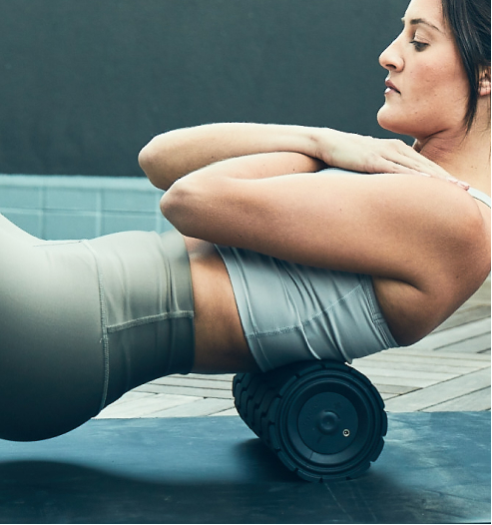
Wave Solo/Roller

This ultra-portable smart vibration therapy device delivers pinpointed pressure and vibration to focused areas for reduced tension and improved movement. Three powerful vibration frequencies and innovative wave texture allow its ergonomic shape to work deep into hard-to-reach areas, while our innovative QuietRoll Technology™ effectively mutes sound and reverberations.

The Wave Roller combines powerful vibration therapy and an innovative wave texture to deliver the most powerful, efficient full-body foam rolling experience. This Bluetooth® enabled vibrating foam roller allows you to connect to the Therabody app for personalized recovery routines, releasing tension and increasing mobility where you need it most.

Using the Wave Roller/Solo
- To turn on the Wave Roller/Solo, firmly press and hold the power button for 1-2 seconds.
- Wave Roller will start on the lowest of five settings, Wave Solo will start on lowest of three settings. To increase speed, short press the plus button until the desired speed is active.
- Place the device under the treatment area gradually applying light to moderate pressure as needed.
- To turn off the Wave Roller/Solo, firmly press and hold the power button until the device turns off.
Battery and Charging
- After turning off the device, plug the power adapter into the charging port.
- The LED light on the power button will flash until fully charged.
- Charging is complete when the LED light on the power button is solid green.
- Battery level is continuously displayed on the LED light of the power button when the device is on. To view battery level when the device is off, briefly press the power button and the LED battery light will flash to indicate the battery level.

Please wipe down Wave Roller/Solo with a sanitation wipe after each use.

